1. Players.csv contains the format of the player file.

2. set up a python project folder or pip install Django only.

3. The required pip files are present in the requirements.txt. Only Django has to be installed.

**pip install Django**

4. Open a terminal.

5. set current directory to \project\ (SHOWN BELOW)

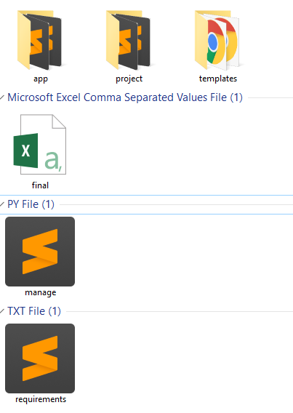

6. Run the following command: (SHOWN BELOW)

**python manage.py runserver**

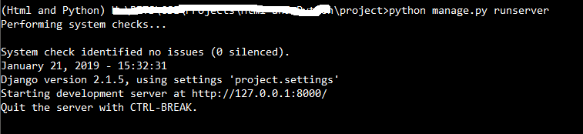

7. Open your browser and enter the below url.

[**http://localhost:8000/login/**](http://localhost:8000/login/)

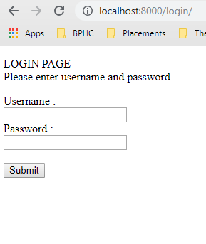

8. You can find the credentials in

**Project/app/views.py**

On line 10, there is a dictionary userCredentials, in which multiple user/pw can be added/removed.